

**School of Computing**

**SRM IST, Kattankulathur – 603 203**

**Course Code: 18CSC206J**

**Course Name: Software Engineering and Project Management**

|  |  |
| --- | --- |
| **Experiment No** | 6 |
| **Title of Experiment** | Design a System Architecture, Use Case and Class Diagram |
| **Name of the candidate** | Shaurya Singh Srinet |
| **Team Members** | Shounak Chandra, Parth Galhotra |
| **Register Number** | RA2111032010006, RA2111032010026, RA2111032010029 |
| **Date of Experiment** | 28.2.23 |

**Mark Split Up**

|  |  |  |  |
| --- | --- | --- | --- |
| **S. No** | **Description** | **Maximum Mark** | **Mark Obtained** |
| 1 | Exercise | 5 |  |
| 2 | Viva | 5 |  |
| **Total** | | **10** |  |

**Staff Signature with date**

**Aim:**

To Design a System Architecture, Use case and Class Diagram

**Team Members:**

|  |  |  |  |
| --- | --- | --- | --- |
| **S. No** | **Register No** | **Name** | **Role** |
| **1** | **RA2111032010006** | **Shaurya Singh Srinet** | **Representative** |
| **2** | **RA2111032010026** | **Shounak Chandra** | **Member** |
| **3** | **RA2111032010029** | **Parth Galhotra** | **Member** |

**SYSTEM ARCHITECTURE**

**Architecture of library management system:**

Library management system has 4 architectures.

1. Add or create user and book.

2. Delete user or book

3. Update information

4. Search book or user

Basic architecture of a library management system is given below:

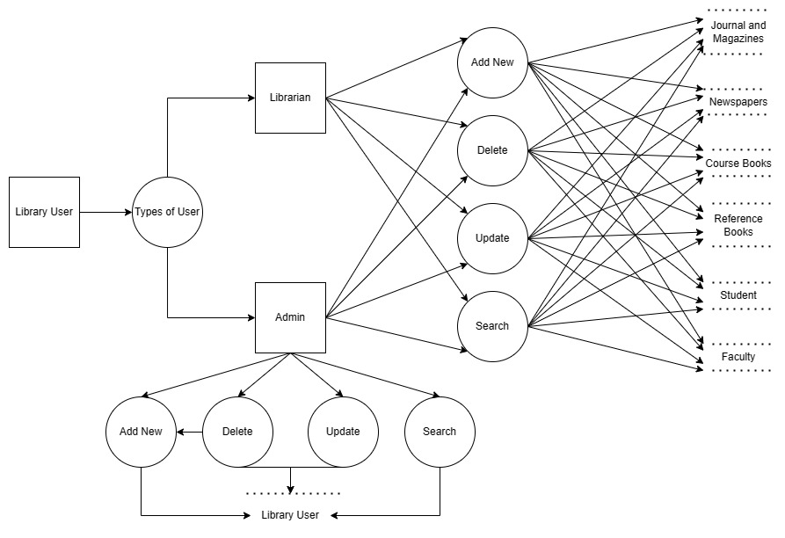

**USE CASE DIAGRAM**

A use case diagram is a graphical depiction of a user's possible interactions with a system. A use case diagram shows various use cases and different types of users the system has and will often be accompanied by other types of diagrams as well. The use cases are represented by either circles or ellipses. The actors are often shown as stick figures.

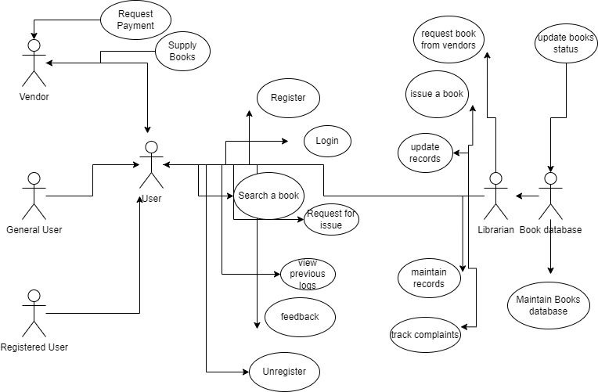

**CLASS DIAGRAM**

Class diagram is a static diagram. It represents the static view of an application. Class diagram is not only used for visualizing, describing, and documenting different aspects of a system but also for constructing executable code of the software application.

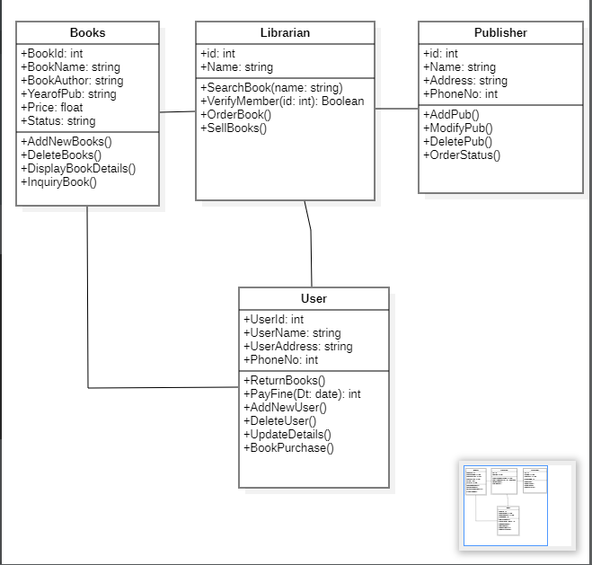

**Result:**

Thus, the system architecture, use case and class diagram created successfully.